Case 5-Asia-China-Cicada Jade Amulets

Resurrection Symbolism in China

Contents

# Introduction

In the fifth millennium BCE Chinese shamans in in the Liao River valley (SE Inner Mongolia, NE Hebei, Liaoning and SW Jilin province in Manchuria) began developing a complex religiosity of the immortality of the soul. This religiosity involved instantiating concepts in jade of sculptures of the shaman’s flight to the sky world’s swirling clouds above the valley and sculptures of the soul’s immortality through life-cycle of the cicada below the valley floor. This culture is known as “Hongshan” (4700-2920 BCE) based on an archaeological site excavated at Hongshanhou (2), in Liaoning province (1) which has produced these jade sculptures of clouds and cicadas in tombs and altars.

It is suggested that the cicada (蝉 Chán) was viewed as a symbol of rebirth and immortality based on its life cycle. The cicada hatches from an egg on a tree branch, falls to the earth as a stubby nymph (first instar, no. 2 below), burrows in the ground, and curls around rootlets (nos. 3-6, below) where it is sustained by the root's nourishment for as many as seventeen years, when it mysteriously emerges into the light of day, climbs the trunk of the tree that has been nourishing it. Then its skin splits open, and its wings unfurl as a mature cicada (no. 7, below). This life-cycle was seen as an analogy for humans being entombed in the earth for "the Chinese regard death as a separation of the vital spirit from the body, and they cling to the belief that the spirit keeps hovering about the body, even after the latter has been deposited in its final resting place" (De Groot 1892, Pt. 2: 16). It was further believed that souls rose on a path to eternal existence in a transcendent realm symbolized by jade cloud sculptures. Therefore, it is suggested that the sculptures both of the cicada’s cycle and the clouds of the sky world were intimately connected. This religiosity persisted for four thousand years, for as late as the Han dynasty (206 BCE–220 CE) jade amulets shaped like winged cicadas were placed on the tongues of corpses to symbolize a hope for rebirth and immortality.

.

**Cammann, Schuyler.** 1953. Types of Symbols in Chinese Art. in Arthur F. Wright, ed., Studies in Chinese Thought. Univ. Chicago Press. pp 195-231 & pls. II-IX

**Eberhard, Wolfram.** 1970. Studies in Chinese Folklore and Related Essays. (Publ. by Indiana Univ. Res. Center for the Lang. Sciences, Bloomington) Mouton & Co., The Hague. IX + 329 pp.

**Laufer, Berthold.** 1974. Jade. A study in Chinese Archaeology and Religion. Dover Publs., New York. (First publ. in 1912 as Fieldiana: Anthropology, v. 10.) XIV + 370 pp. + 68 pls.

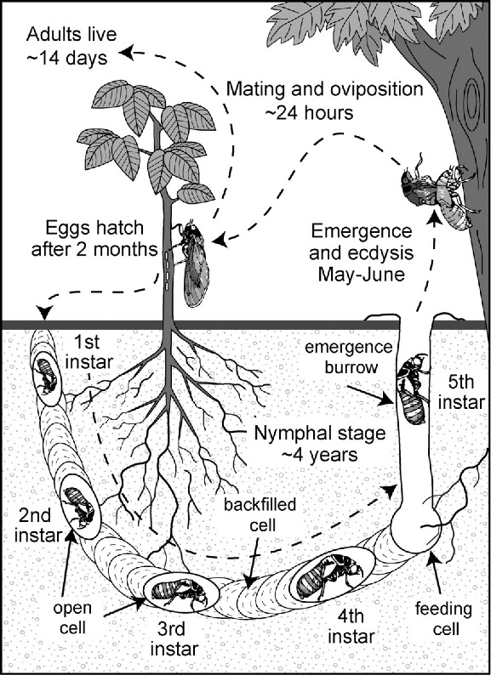 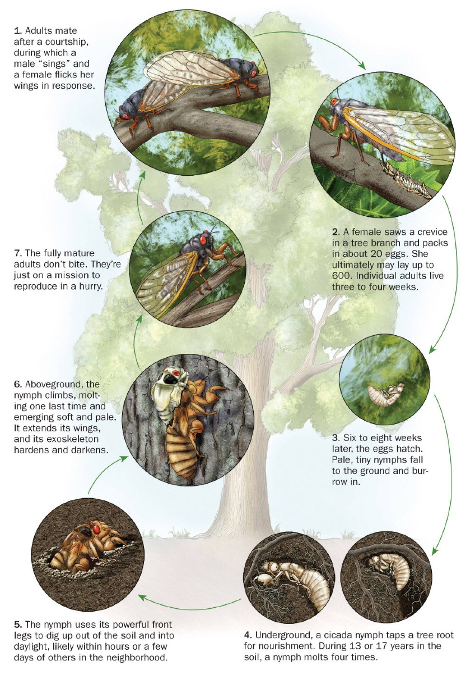

and incorporated it into their spirituality of resurrection can be applied to

the “dead” cicada larva “resurrected” into new life as it emerges from the ground

and ascends as a nymph into trees after its hibernation,

or the burrowed boar in winter emerging from its underground den from a state of semi-hibernation

or the philosopher emerging from the darkness of ignorance emerging into enlightenment

or the deceased individual emerging from an entombment with a jade cicada placed in its mouth as the symbol of resurrection

In addition, Huechys sanguinea (chu-ki, “red cicada”) with its red and black carapace is used as a blistering agent” Clausen (10) Chou (9)

# Cicada First Instar Amulet

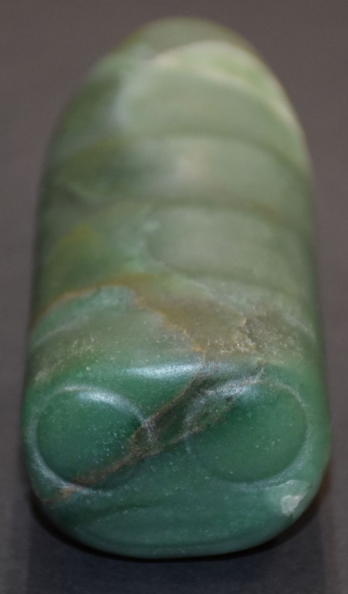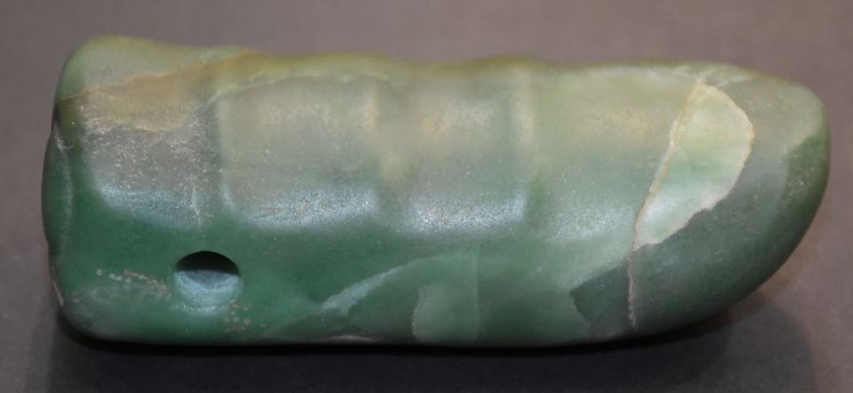

L 4.0 inch W: 1.7 inch H: 1.4 inch

L : 10.0 cm W: 4.2 cm H: 3.5 cm

# Cicada Larva Amulet

2) Hongshan-Liaoning-Cicada Larva Amulet-Jade-4700-2920 BCE

 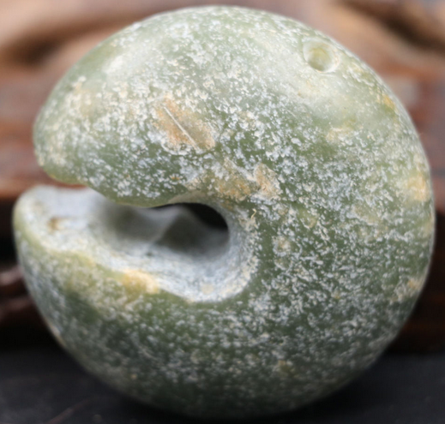 

This example of a Cicada Larva Amulet (note hole for suspension) emulates the larval stage of the cicada as it first enters its hibernation stage underground. H 5.4 cm, W 5.4 cm, T 2.4 cm. Atlantica Collection.

**Formal Label:** Asia-China-Hongshan-Cicada Larva Amulet-Jade-4700-2920 BCE

**Display Description:**

This example of a Cicada Larva Amulet symbolizes the life cycle of the cicada which begins as a nymph that having hatched from an egg on a tree branch, falls to the earth as a larva, burrows in the ground, and attaches to rootlets where it is sustained by the root's nourishment for as many as seventeen years when it is mysteriously called into the light of day, climbs the trunk of the tree, its skin splits open, and its wings unfurl as a mature cicada.

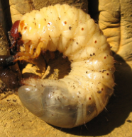

Cicada Larvae after https://www.flickr.com/photos/marielosp/139126776

The resurrection metaphor can be applied to either that of the dead being resurrected into new life or in the case of the philosopher emerging from the darkness of the enclosed study being resurrected into the world of light. As De Groot (1892, Pt. 2: 16) remarks "the Chinese regard death as a separation of the vital spirit from the body, and they cling to the belief that the spirit keeps hovering about the body, even after the latter has been deposited in its final resting place." The present figurine according to this interpretation would signify the hovering spirit of the deceased prior to its final emergence as a cicada. Three phases of the emergence of the resurrected spirit represented in Chinese jades from the anthropomorphic, to the quasi anthropomorphic to the true cicada are in the Field Museum of Natural History, Chicago (Harman 1974)**:**

**References:**

Hartman, Joan M. 1974. “[An Interesting Han Jade in the Los Angeles County Museum of Art](https://www-jstor-org.libproxy.mit.edu:9443/stable/3249710),”

[*Artibus Asiae*,](http://www.jstor.org.libproxy.mit.edu/action/showPublication?journalCode=artibusasiae)  Vol. 36, No. 1/2, pp. 55-64

De Groot, J.J.M. 1892-1910. *The Religious System of China*. Leyden, E.J. Brill, 1892-1910. 6 vols

# Cicada Larva - Boar Amulet

Case 5-Asia-China-Hongshan-Liaoning-Boar Cicada Amulet aka Pig Dragon-Jade-紅山 - 遼寧 - 豬龍-玉-2.4 in

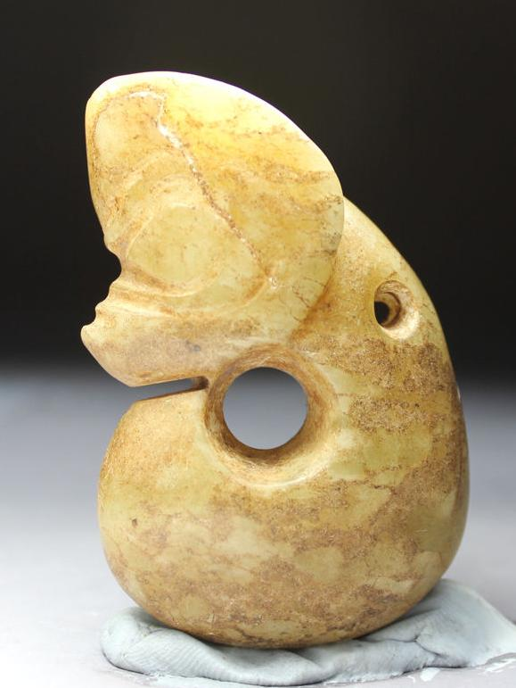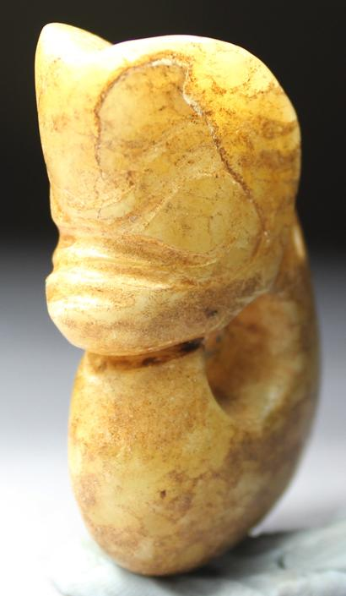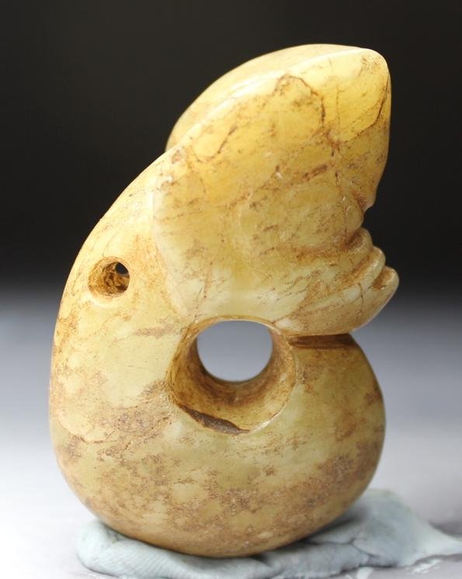

Figs. 1-3. Hongshan-Liaoning-Pig Dragon-Jade-紅山 - 遼寧 - 豬龍-玉-8.5 in

**Case no.: 5**

**Accession Number: A000**

Formal Label: Hongshan-Liaoning-Pig Dragon-Jade-紅山 - 遼寧 - 豬龍-玉-8.5 in

**Display Description:**

This Hongshan “Boar-Cicada Amulet” (previously and erroneously called a “Pig-dragon”) is a jade carving from Liaoning (紅山-玉--豬頭龍--建平--遼寧).It is a zoomorphic, figurine with a boar-like snout and pointed ears on an elongated, serpentine, limbless body, coiled around a central axis which emulates the larval stage of the cicada, which incorporated important religio-philosophical principles in Hongshan China.



Cicada Larvae after https://www.flickr.com/photos/marielosp/139126776

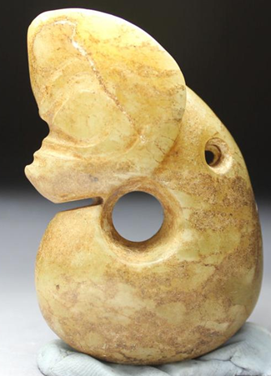

Boar-Cicada Amulet-Jade

野豬作為蟬玉

Yězhū zuòwéi chán yù - H 8.5 in

Early Hongshan “Boar-Cicada Amulet” jade carvings (ca 5000 BCE) have stout, pig-like bodies, while later Hongshan examples (ca 3000 BCE) have slender, serpentine bodies. Since “Boar-Cicada Amulet” jade carvings have been excavated as Hongshan grave goods (Howard 2006), and since boar bones have accounted for 60 percent of animal bones recovered from Hongshan sites, it is inferred that boars were important not only for the Hongshan economy but also for their symbolic significance. The melding of a larval cicada shape with that of a boar coupled an important economic icon with the cicada, the symbol of resurrection, producing a powerful Hongshan foundational image.

This cicada resurrection amulet in traditional China was based on the life cycle of the cicada which begins as a nymph that having hatched from an egg on a tree branch, falls to the earth, burrows in the ground, and attaches to rootlets where it is sustained by the root's nourishment for as many as seventeen years when they are mysteriously called into the light of day, climb the trunk of the tree, their skins split open, and their wings unfurl as mature cicadas.

The resurrection metaphor can be applied to that of the apparently dead cicada being resurrected into new life as it ascends into trees after its hibernation, or the burrowed boar in winter emerging from its underground den from a state of semi-hibernation or in the case of the philosopher emerging from the darkness of the enclosed study being resurrected into the world of light. As De Groot (1892, Pt. 2: 16) remarks "the Chinese regard death as a separation of the vital spirit from the body, and they cling to the belief that the spirit keeps hovering about the body, even after the latter has been deposited in its final resting place." The present figurine of a boar-cicada couples the power of the boar (economically and physically) with the assurance of the emergence into the light of day from the boar’s underground den.

 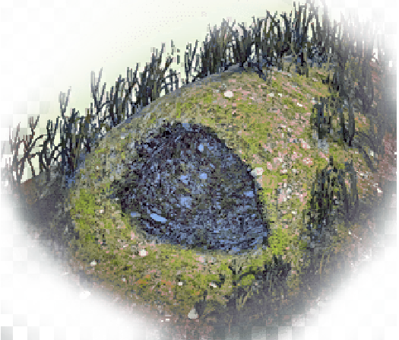

Left: Two wild red boars emerging from an earthen den much like the cicada does in its life cycle. After https://encrypted-tbn0.gstatic.com/images. Right: a red boar’s den. After https://bddatabase.net/items/ui_artwork/ic_04126.png.

Red Boars have excellent tunneling skills, and they can accommodate several Red Boars in a single den.

**LC Classification:**

**Date or Time Horizon:**

**Geographical Area:** Liaoning Province

**Map:**

**GPS coordinates:**

**Cultural Affiliation:** Hongshan

**Medium:** jade

**Dimensions:** **H 2.4 in, W1.5, D 0.7 in**

**Weight:**

**Condition: original**

**Provenance:** Jianping

**Discussion:**

In contrast to the Graeco-Roman and Judaeo-Christian-Muslim notions of the soul as the essence of a human being, the Hongshan people of ancient China regarded the soul as the source of their material sustenance that is composed of beings, both animal and human, that personify the bodily essence of their native selves.

To the Hongshan people the pre-eminent animal was the wild boar that was originally hunted in the Mulanshan -- mountains of great, natural wilderness. Images of Mulanshan were conceived by Hongshan sculptors of jade, the stone of immortality, as rounded summits with burrows of the wild boar as circular hollows within these mountains. Images of the wild boar were sculpted on the ends of these mountains -- with their hollows -- making the identity of the sculpture explicit. Thus, this entire sculpture – boar, mountain and burrow -- became the emblem of the Hongshan essence of life.

To further exemplify the source of this essence of life, images of the wild boar as a curled-up cicada about to emerge from the earth, were also sculpted from jade. These sculptures ranged in size from personal amulets to large figures hung in ritual sanctuaries. Their presence was intended to recall the time when these wild boars were first captured and then later domesticated for animal husbandry, thereby marking the moment at which the Hongshan culture emerged from its hunting-gathering existence into a Neolithic, sedentary existence capable of creating such provocative reminiscences of the ancient past.

The Hongshan conception of culture and community required that all participate in this memory of the ancient ways of hunters who could assume the personae of the hunted so that the life of their communities could be sustained in an otherwise alien world. To understand the Hongshan self, one needs to be open to assume this shamanic posture of ecstasy, of being able to stand outside of one’s self and to assume the identities of nature -- both wild animals and humans -- without alterity or division. Furthermore, this was a call to assume the blending of souls, the breaking down of one’s ego and one’s acceptance of the Other. Only this opens a window into one’s own identity and alterity, and with it one’s extension of the

# Cicada Boar and Den Amulet

 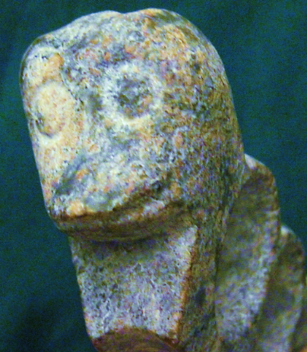

The resurrection metaphor was applied to the boar emerging from his den into the light of day The present figurine of a boar-cicada couples the power of the boar (economically and physically) with the assurance of the emergence into the light of day from the boar’s underground den.

 

Left: Two wild red boars emerging from an earthen den much like the cicada does in its life cycle. After https://encrypted-tbn0.gstatic.com/images. Right: a red boar’s den. After <https://bddatabase.net/items/ui_artwork/ic_04126.png>. Red Boars have excellent tunneling skills, and they can accommodate several Red Boars in a single den.

# Cicada Nymph (Fifth Instar) - Boar Amulet

4) Hongshan- Boar-Cicada Amulet-Jade-4700-2920 BCE

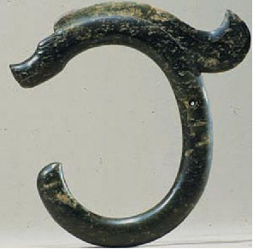

野豬作為蟬玉

Yězhū zuòwéi chán yù -

This jade Cicada-Boar Amulet has the blunt snout of *Sus scrofa* and the serpentine shape with an emergent crest of the fifth instar of the cicada nymph. In this rendition the cicada nymph shape is enlarged for greater emphasis on the metaphysical sense of the cicada’s re-emergence or resurrection into new life.

# Cicada Sheep Amulet

**Cicada-Sheep sculptures were developed as the Hongshan Culture began to depend on a sheep economy as Trade and Exchange Expands into Mongolia**

Sheep sculptures were added by artisans to their Cicada-Boar repertoire as Hongshan trade and exchange with Mongolian sheep herders developed. This suggests increasing cultural complexity and stability, although the degree of complexity and Hongshan connections to other emergent Neolithic cultures in Mongolia and Central Asia are still under debate (Guo 1985).



 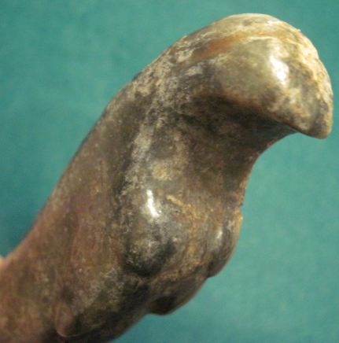

Rare mid-late Hongshan sheep sculpture, ca 2500 BCE, Atlantika Collection

# Cicada-Hongshan Shaman Amulet

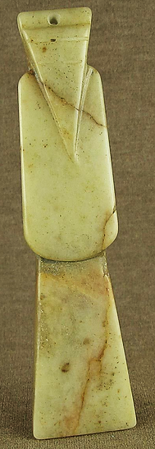

**LC Classification:** NK5750.2.C6

**Date or Time Horizon:** 4700-2920 BCE

**Geographical Area:** Inner Mongolia-Ogniud (Wengniute) Banner-Sanxingtala

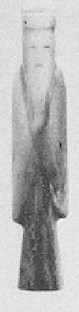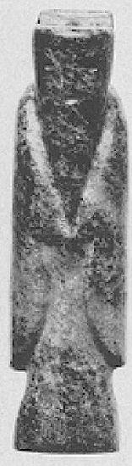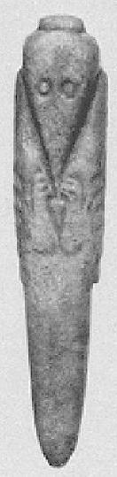

**Field Museum of Natural History, Chicago, Nephrite philosopher pendants, anthropomorphic- quasi cicada. After Hartman 1974, Figs. 8 c, a, b**

**References:**

**Hartman, Joan M. 1974. “**[**An Interesting Han Jade in the Los Angeles County Museum of Art**](https://www-jstor-org.libproxy.mit.edu:9443/stable/3249710)**,”**

[***Artibus Asiae,***](http://www.jstor.org.libproxy.mit.edu/action/showPublication?journalCode=artibusasiae)  Vol. 36, No. 1/2, pp. 55-64

**De Groot, J.J.M. 1892-1910. *The Religious System of China*.** Leyden, E.J. Brill, 1892-1910**. 6 vols.**

# Cicada Han Tongue

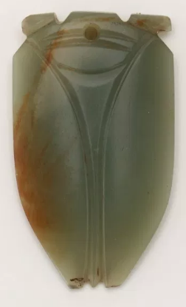

# Cicada-Tang Philosopher Amulet

**Case 5-Asia-China-Pendant-Philosopher-Jade-Tang-750 CE**

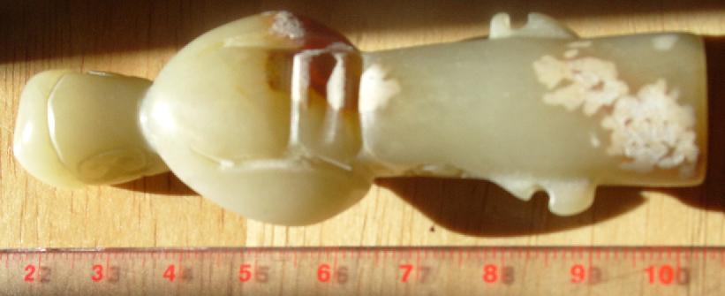 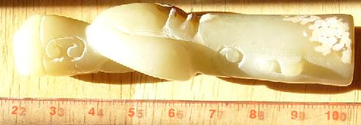 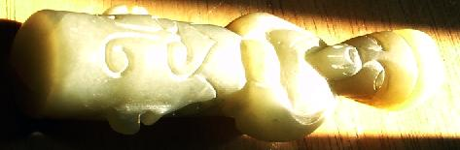

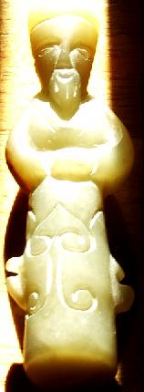

**Case no.: 5**

**Accession Number: A000**

**Formal Label: China-Pendant-Philosopher-Jade-Tang-750 CE**

**Display Description:**

**This anthropomorphic pendant, carved of pale grey-white nephrite with rust-brown areas. There is some alteration of the jade which has a smooth polish and edges. The front- bottom of the pendant is incised with bilaterally symmetrical arcs that encompass pendant holes that are now worn out but once held a pendant string. This arrangement of the pendant holes indicates the when originally worn, the pendant figure would have been suspended up-side-down. This type of suspension may have signified that the figure displayed was deceased and the act of suspending it up-side-down was in reference to its spiritual state.**

**The cicada resurrection amulet in traditional China was based on the life cycle of the cicada which begins as a nymph that having hatched from a egg on a tree branch, falls to the earth, burrows in the ground, and attaches to rootlets where it is sustained by the root's nourishment for as many as seventeen years when they are mysteriously called into the light of day, climb the trunk of the tree, their skins split open, and their wings unfurl as mature cicadas.**

**LC Classification:** NK5750

**Date or Time Horizon:** **Tang-750 CE**

**Geographical Area:**

**Map:**

**GPS coordinates:**

**Cultural Affiliation:** Tang

**Medium:** **nephrite, pale grey-white**

**Dimensions:** **H 8.26 cm, 3.25 in**

**Weight:**

**Condition: original**

**Provenance:**

**Discussion:**

**The resurrection metaphor can be applied to either that of the dead being resurrected into new life or in the case of the philosopher emerging from the darkness of the enclosed study being resurrected into the world of light. As De Groot (1892, Pt. 2: 16) remarks "the Chinese regard death as a separation of the vital spirit from the body, and they cling to the belief that the spirit keeps hovering about the body, even after the latter has been deposited in its final resting place." The present figurine according to this interpretation would signify the hovering spirit of the deceased prior to its final emergence as a cicada. Three phases of the emergence of the resurrected spirit represented in Chinese jades from the anthropomorphic, to the quasi anthropomorphic to the true cicada are in the Field Museum of Natural History, Chicago (Harman 1974):**

================================================================================

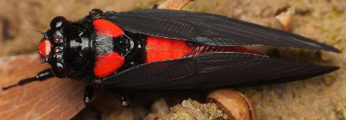

ER-Huechys sanguinea DEGEER 42. Er appears in the Erh Yah as the tenth cicada and is considered by a number of writers as a synonym for the eleventh one, han-diau. But han-diau, as shown in the next paragraph, appears to be a different species which is somewhat superficially related to the er. Er is used here in YANG SHIUNG'S sense, who describes it in his Local Dialect as black and red. The combination of these two colors suggests that it might be the famous medicinal cicada, H. sanguinea. Its complication with the Fulgorid, Lycorma delicatula in the Pentsao, as appeared in European literature, will be discussed elsewhere.

h) HAN-CHIANG-Scieroptera splendidula FAB. 43. Han-chiang is first introduced by Kou Pu and is generally considered by most writers as the han-diau of the Erh Yah and the han-tchen of the Book of Odes. Both Kou Pu and LI SHIH- CHEN describe it as greenish-red but Ho YI-SHING states that it is greenish-yellow. The latter also makes the remark that it is the chu-liang of the common people and that the sound it produces is somewhat " yuyi... yuyi... yuyi." It appears to the present writer that the han-chiang of Kou Pu might be S. splendidula and Ho YI-SHING'S chu-liang might be simply a variety. In Japan, han-chiang is taken as Meimuna operlifera. But the Chinese description, as given by different writers, does not seem to agree with this species.

i) HuI-Ku-Mogannia cyanea WALKER. 44. The hui-ku has a long list of synonyms and is generally considered as the ting-shiu or shilu of the Erh Yah. Hui-ku, however, is the one best known in literature and, according to the Local Dialect, a local name used in Hunan and Hupeh. It was first described by TAO HUNG-CHING as purplish-blue and begins to sing in the fourth and the fifth month. Further details were given by Ho YI-SHING who wrote: " The deh-lao begins to sing in the seventh month by calling its own name. It is a small and slender cicada with a bluish-green color and is known as fu-de-fu-liang in Fengtien." The discrepancy about the time of appearance is due perhaps to the fact that TAO HUNG-CHING was a native of Nanking while Ho YI-SHING was born in Shantung. The color and the size suggest that this hui-ku might be what we know in science as M. cyanea. In Japan, hui-ku is identified with P. kaempferi, a species which can hardly be said to agree with the Chinese description.

TSAN-Gaeana sp. 45. This insect made its first appearance with H. sanguinea and M. operlifera in the Local Dialect and was described by YANG SHIUNG as large and black. Ho YI-SHING considered it as the pi-diau or wang-fu of the Erh Yah. The fact that it was compared with sanguinea and operlifera suggests that this large black cicada might refer to some species of the genus Gaeana. 46. According to Wu's catalogue, several species of this genus are known to occur in China. No records have been reported

Black Cicada (Cryptotympana pustulata)

Cicadas are commonly found in mainland China, Taiwan, and Japan. They had religious significance in ancient China, and symbolized reincarnation or immortality, as the Chinese compared the cicada's periodic molting of its shell with a person's leaving the physical body behind at the time of death. Bronze vessels as old as 1500 B.C. ornamented with cicadas have been found in Chinese tombs, along with white pottery and jewelry featuring cicada designs.

Distribution: Shandong, Hebei, Henan, Jiangsu, and other provinces. Most parts of China.

Charateristic: Size about 37 - 39 mm, female bigger. Black body color, head, chest backplane with shiny, black abdomen, Jianchi latter part of the orange-red wing veins, abdominal flap black male, elliptic, lateral margin of the red brown, foreleg leg of red, black margin, with the tibia, the following sections are black, in the foot after a while section tibia orange, black stripe. Living in the plains and low-elevation mountains, adult occurred in June to September, sounding in daytime.

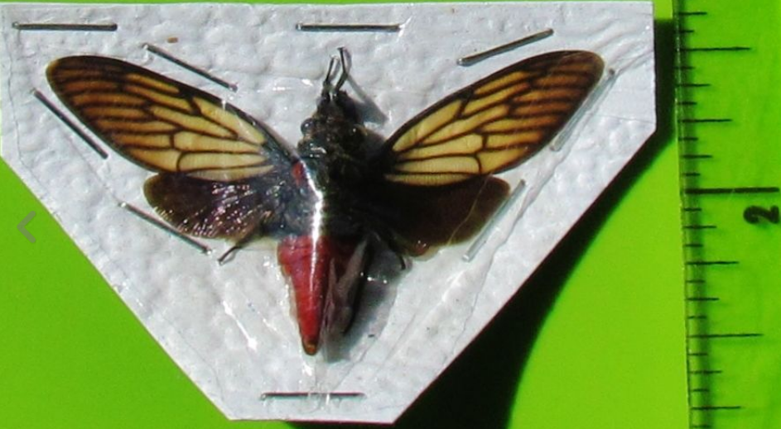

**Red Devil Cicada Huechys incarnate**

|  |
| --- |
| [Cicadidae - Huechys sanguinea.JPG](https://en.wikipedia.org/wiki/File:Cicadidae_-_Huechys_sanguinea.JPG) |
|  |
| [*Huechys sanguinea*](https://en.wikipedia.org/wiki/Huechys_sanguinea) |

============================================================================

At ca 8,000 BCE four sites in three provinces attest to the beginnings of agriculture identified by excavated domesticated phytoliths paired with solely wild faunal remains (Huang 1966; Yan 1997): Hebei (the Nanzhuangtou site 39° N lat. in Xushui County, Baoding Institute et al. 1992), Hunan (the Yucanyan site in Dao County, 25.5° N lat.) and Jiangxi (Xianrendong and Diaotonghuan 28.5° N lat., Yan 1997, in Wannian County). These sites represent transitional Hunter-gatherer / Neolithic cultures.

At ca 6,000 BCE Asians with the D haplogroup living in the Yangtze River delta domesticated both foxtail millet (Wu et al. 2007) and wild boars. In Hebei (Wu’an County, 36.5° N lat.) at the Cishan site (Jing and Flad 2002) burial pits of domesticated wild boars were overlain by charred, domesticated foxtail millet (Jing and Flad 2002; Jing et al. 2008). Domesticated foxtail millet, a C4 plant that cycles CO2 into four-carbon sugar compounds, is very efficient in hot, dry climates and was an important component of both the human and swine diets (Jing and Flad 2002). The discarded chaff of domesticated cereals appears to have been used to feed wild boars. Domesticated wild boars have been identified by tooth size (lower 3rd molar L41.4, W 18.3), age at slaughter (> 60%, .5-1 yr.) and archaeological context such as ritual burial of entire skeletons beneath charred foxtail millet.

These emergent Neolithic Hongshan people, who secured both economic control over these two inter-related animal and plant food resources and consolidated their political power through manipulation of these resources of productive wealth, were speakers of Altaic, either pre-Mongolic or Korean but not Sinitic (Blench 2004; but see Guo 1995).

By 6000 BCE the Yangtze River delta had emerged as an area of importance for the development of a dual domesticated boar and foxtail millet economy. In order to gain the respect of the masses political élites doled out to the commoners not only grain and pork (Flannery 1968, Bradley 1972, Frankenstein and Rowlands 1978, Kristiansen 1991, Saenz 1991) but also prestige goods such as jade and silk (Firth 1965; Leach 1970:162-63).

**6) Climatic fluctuations 4000-2200 BCE**: **development and demise of the Hongshan culture.**

Between 3678-3400 cal. BCE the climate was colder and drier than today. Then, from 3400- 2800 cal. BCE the climate was much warmer and wetter. Between 2800-2300 cal. BCE the climate was persistently cold, with an exceptionally cold event occurring between 2600-2300 cal. BCE. This cold event was recorded at several other localities in Northern China and in the Northern Hemisphere. It played an important role in the emigration of Inner Mongolian people from the Hunshandake Sandy Lands of Inner Mongolia (Yang et al. 2015) to immigrate to the Yangtze River delta and in turn they forced the Hongshan people to emigrate to Taiwan by 2200 BCE, a date that corresponds to the demise of the Hongshan culture which has been an enigma until now (Jin and Liu. 2002).



Map showing location of Hunshandake Sandy Lands outlined in black.

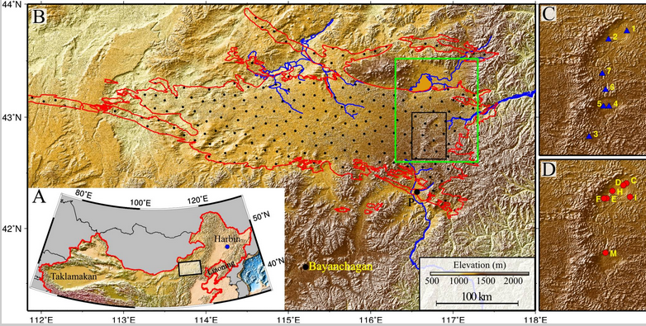

Geographical location of the Hunshandake Sandy Lands (A) and its area (encompassed by red line in B).

The black rectangle in B marks the location of the enlarged maps C and D on the Right, and the green rectangle shows the location of [Fig. 2](https://www.ncbi.nlm.nih.gov/pmc/articles/PMC4311860/figure/fig02/). Map C shows the localities of water samples, and map D shows the localities of stratigraphy The sand–paleosol section P ([Fig. 3](https://www.ncbi.nlm.nih.gov/pmc/articles/PMC4311860/figure/fig03/)) is on the southern margin, and the site Bayanchagan marks the coring site to sample the paleosols (Jiang et al. 2006). Rivers with headwaters in the Hunshandake likely formed by groundwater sapping are marked in blue. Drainages to the southwest and west are currently undergoing groundwater sapping, with substantial spring-driven flow found at the current river base level. From <https://www.ncbi.nlm.nih.gov/pmc/articles/PMC4311860/figure/fig01/>

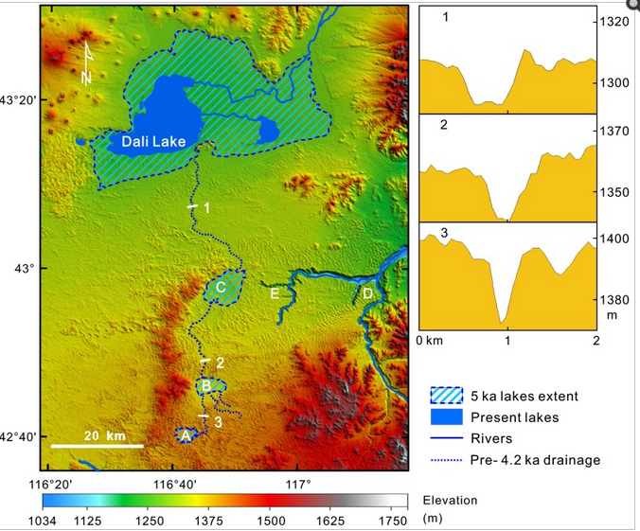

Map of the desiccation of Holocene lakes and channels in the Hunshandake Sandy Lands at selected epochs (Yang *et al*. 2015). Upper, middle, and lower lakes are indicated by points A, B, and C, respectively. Xilamulun River (point D) drains to the east. Groundwater-sapping headcuts at the upper reaches of incised canyons (point E) suggest a mid-Holocene interval of easterly surface flow, followed by groundwater drainage beginning at the ca. 4.2 ka event. Northern and central channels at point E are currently abandoned, and groundwater sapping has migrated to the southerly of the three channels shown. (Right) Cross-sections of the predrainage shift, northerly drainage into Dali Lake (Localities shown on the Left), showing the increase in widths of channels downstream (Vertical exaggeration ∼30:1).

**References**

Anderson, E. N., JR. I988. *The food of China.* New Haven: Yale University Press.

Blench, Roger. 2004. “Human migrations in continental East Asia and Taiwan: genetic, linguistic and archaeological evidence. Université de Genève” [DRAFT CIRCULATED FOR COMMENT]

Chang K. C. I977. *Food in Chinese culture*. New Haven: Yale University Press.

1986. 4th edition. *The archaeology of ancient China*. New Haven: Yale University Press.

1989. "Ancient China and its anthropological significance." In *Archaeological thought in America*. Edited by C. C. Lamberg-Karlovsky, pp. I 55-66. Cambridge: Cambridge University Press.

Childs-Johnson, Elizabeth (1991). "Jades of the Hongshan culture: the dragon and fertility cult worship," Arts asiatiques, **46**: 82–95.

Cohen, M. N., and G. J. Armelagos.1. *Paleopathology at the origins of agriculture*. Orlando: Academic Press.

Freid, M. H. I967. The evolution of political society. New York: Random House.

Freidman, J., and M. J. Rowlands. I978. "Notes towards an epigenetic model of 'civilization,"' in *The evolution of social system*. Edited by J. Friedman and M. Rowlands, pp. 20I-76. London: Duckworth.

Gao, G. I978. “Dawenkou culture its nature and chronology” (大汶口文化的性质和年代), *Kuangmingribao*, April 27.

Guo, Da-Shun 1995. Hongshan and related cultures. In: *The archaeology of Northeast China: beyond the Great Wall.* Nelson, Sarah M. ed. 21-64. London and New York: Routledge.

Guo D. *Hongshan Culture(红山文化*). Artifacts Press; Beijing: 1985.

Jiang W, et al. 2006. Reconstruction of climate and vegetation changes of Lake Bayanchagan (Inner Mongolia): Holocene variability of the East Asian monsoon. Quat Res. 65(3):411–420.

Jin, G. and Liu, D. 2002. Mid-Holocene climate change in North China, and the effect on cultural development. *Chinese Science Bulletin*, *47*(5), pp.408-413.

Jing Y, Flad R. 2002.” Pig domestication in ancient China,”. Antiquity 76: 724–732.

Jing Y, Jianlin H, Blench R. 2008. “Livestock in ancient China: an archaeo-zoological perspective.” In: Sanchez-Mazas A, Blench RM, Ross M, eds. Human Migrations in Continental East Asia and Taiwan. Genetic, Linguistic and Archaeological Evidence. Routledge; Abingdon: New York.

Johnson, A. W., and T. Earle I987. *The evolution of human society: From foraging group to agrarian state*. Stanford: Stanford University Press.

Keibel F. 1897. *Normentafeln zur Entwicklungsgeschichte der Wirbelthiere*, (*Sus scrofa domesticus*). Bd. 1. Jena: Fisher, v. 1, pl. 2, no. 16.

Kaogu. I979. “Summary of the debate on the nature of Dawenkou society and related questions (关于大汶口社会性质辩论及相关问题的总结),” *Kaogu*, no. I, pp. 33-36.

Larson G, Dobney K, Albarella U, Fang M, Matisoo-Smith E, Robins J et al. 2005. “Worldwide phylogeography of wild boar reveals multiple centers of pig domestication,” *Science* 307: 1618–1621.

Larson G, Liu R, Zhao X, Yuan J, Fuller D, Barton L et al. 2010. « Patterns of East Asian pig domestication, migration, and turnover revealed by modern and ancient DNA,” *Proc Natl Acad Sci USA* 107: 7686–7691.

Lee, Y. I96I. “Mortuary practices of Wa people and the research on burial practices in prehistoric China (佤族的太平间做法，在中国史前丧葬习俗研究),” *Kaogu*, no. 7, pp. 37I-74.

Rappaport, R. 1967. *Pigs for the ancestors*. New Haven: Yale University Press.

Sahlins, M. A. I970. "Poor man, rich man, big-man, chief: Political types in Melanesia and Polynesia," in *Cultures of the Pacific*. Edited by T. G. Harding and B. J. Wallace, pp. 203-I5. New York: Free Press. . I972. Stone Age economics. New York: Aldine.

Sanders, W. T., and D. Webster. I978. "Unilinealism, multilinealism, and the evolution of complex societies," in *Social archaeology: Beyond subsistence and dating*. Edited by C. Redman, M. Berman, E. Curtis, W. Langhorne, N. Veraggi, and J. Wanser, pp. 249-302. New York: Academic Press.

Saxe, A. I970. *Social dimensions of mortuary practices*. Ann Arbor: University Microfilms.

Service. 1962. *Primitive social organization*. New York: Random House.

I975. *Origins of the state and civilization*. New York: Norton.

Shandong Provincial Museum. *I978.* “Remarks on Dawenkou culture (论大汶口文化),” *Wenwu,* no. 4, pp. 58-66.

Tang, L. I977. Origins of earliest culture in China as seen from the writing on pottery (从陶器文字看中国最早的文化起源). *Kuangmingribao*, July I4.

I978. “A discussion of the nature of the Dawenkou culture and the writing on pottery (论大汶口文化的性质与陶瓷文字),” *Kuangmingribao,* February 23.

Taylor, D. I975. “Some locational aspects of middle-range hierarchical societies.” Ph.D. diss., City University of New York.

Tong C. I974. “The origins of private ownership and social stratification in Chinese archaeology,” *Kaogu,* no. 4, pp. 2I3-2I.

Wang, R. I98I. “The religious significance of interring pig carcasses in the Chinese Neolithic (中国新石器时代中国猪尸屠体的宗教意义),” *Wenwu*, no. 2, pp. 79-85.

Wei, J. I976. “Discussion of origins of hierarchical societies in ancient China: An analysis of archaeological data in prehistoric societies (中国古代等级制社会的起源：史前社会考古资料分析),” *Wenwu*, no. 8, pp. I-5.

Wu, J. 1982. “The chronology of Shandong archaeology and related questions (山东考古年表及相关问题),” *Wenwu*, no. IO, pp. 44-56.

Wright, H. I984. "Pre-state political formations," in *On the evolution of complex societies*. Edited by T. Earle, pp. 47-77. Malibu: Undena.

Yang, X., L.A. Scuderi, X. Wang, L.J. Scuderi, D. Zhang D., H. Li, S. Forman, Q. Xu, R. Wang, W. Huang, S. Yang. 2015. “Groundwater sapping as the cause of irreversible desertification of Hunshandake Sandy Lands, Inner Mongolia, northern China,” [*Proc Natl Acad Sci U S A*.](https://www.ncbi.nlm.nih.gov/pubmed/25561539)  Jan 20;112(3):702-6.